

Chinese Society for Corrosion and Protection (CSCP)
NACE International China Office

Invite you to

CSCP-NACE Dinner Party at CORROSION 2016

Please join us to receive an update on CSCP from our President and Secretary-General, and to network with corrosion experts from China and other countries.

Date
Sunday, March 6, 2016

Time
7:30 to 9:30 p.m.

Location
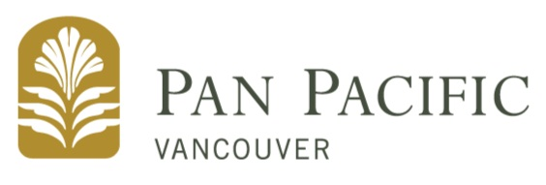
Gazebo 1, Pan Pacific Vancouver,
Canada Place Vancouver,
British Columbia V6C 3B5, Canada

All food and drinks will be sponsored by CSCP and NACE International
and will be FREE to all participants.

We hope you will be able to join us!

Please RSVP to dawzhang@126.com by March 1st, 2016.
Please be sure to include your name, your affiliation,
and the names of each of your guests in your RSVP email.

