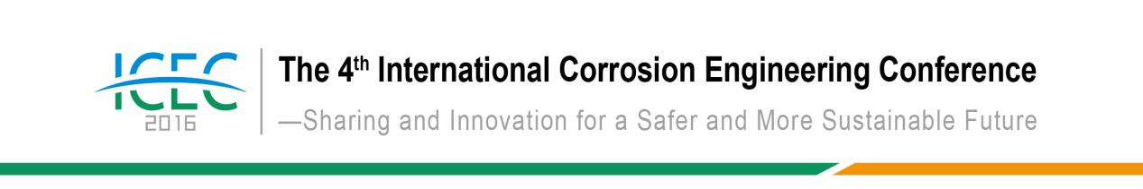

Dear Honored Guests,

It is my greatest pleasure to welcome you all to the 4th International Corrosion Engineering Conference (ICEC2016), which will be held on August 8-11, 2016 in Beijing, China. ICEC2016 is organized by the Chinese Society for Corrosion and Protection (CSCP), with the support from Chinese governmental agencies, universities and research institutions, and also domestic and international industry partners.
Founded in 1979, CSCP has been the central network for corrosion scientists and engineers in China and is currently consisted of over 20,000 individual members and ~160 group members from both academics and industries. For over 30 years, CSCP has been dedicated in advancing corrosion mitigation in China and globally through promoting corrosion research and education.
The ICEC is established to be an international forum for the broad aspects in corrosion science, technology and engineering, with emphasis on corrosion control in different industrial sectors as well as on international infrastructure projects. It was first organized by Corrosion Science Society of Korea in 2007, followed by the Vietnam Corrosion and Metal Protection Association in 2010 and the Libyan Corrosion Society in 2014.
The technical sessions in ICEC2016 will include corrosion in marine applications, oil & gas industries, energies and utilities, coatings and surface technologies, corrosion inspection and monitoring, corrosion modeling and simulations, and also corrosion issues with advanced materials and emerging applications. A trade show will also be offered to demonstrate the most recent innovations in corrosion mitigations from exhibitors worldwide. During the conference, a special event will be also organized to officially launch a new journal – npj Materials Degradation, published by CSCP and Nature Publishing Group.
ICEC2016 will provide with an excellent opportunities to share your experience, research and innovations to your old and new friends in the world corrosion community.
Thank you in advance for your support and contribution. I look forward to seeing you in Beijing!

Sincerely,
Xiaogang Li
Conference Secretary-General
Vice President and Secretary-General of CSCP
Topics
1. Marine Industry
2. Transportations
3. Oil & Gas Industry
4. Energy and Utilities
5. Coatings and Surfaces
6. Inspection and Monitoring
7. Advanced Materials and Emerging Applications
8. Corrosion Informatics

Organization
Host: Chinese Society for Corrosion and Protection
Organizers: National Environmental Corrosion Platform
Corrosion and Protection Center, University of Science & Technology Beijing
Supporter: China Association for Science and Technology
National Science & Technology Infrastructure Center
Media: China Gateway to Corrosion and Protection
npj Materials Degradation
Journal of Chinese Society for Corrosion and Protection
Corrosion Science and Protection Technology
Corrosion & Protection Fan
China Surface Engineering
Equipment Environmental Engineering

Conference Chairs: Baorong Hou, Fuhui Wang
Conference Secretary-General: Xiaogang Li
Advisory Committee: TBD
Organizing Committee (By last name alphabetical order) :
Khalid M. Al-Nabulsi | Saudi Aramco, Saudi Arabia
Daniel J. Blackwood | National University of Singapore, Singapore
Faris O. Dawoud | Saudi Arabian Oil Company, Saudi Arabia
Cuiwei Du | University of Science & Technology Beijing
Shiwei William Guan | Bredero Shaw, Singapore
Nguyen Duc Hung | Vietnam Corrosion & Metal Protection Association, Vietnam
Her-Hsiung Huang | National Yang-Ming University, Taiwan
Yoshinori Isomoto | Hiroshima University, Japan
Hideki Katayama | National Institute for Materials Science, Japan
Youngsik Kim | Andong National University, Korea
Jae-Bong Lee | Kookmin University, Korea
Xiaogang Li | University of Science & Technology Beijing
Jiunn-Shyong Luo | Industrial Technology Research Institute, Taiwan
V.S. Raja | Indian Institute of Technology Bombay, India
Mingxian Sun | China Ship Scientific Research Center, affiliated to China Shipbuilding Industry Corporation
Ahmed Torky | Libyan Corrosion Society, Libya
Nguyen Nhi Tru | Vietnam Corrosion & Metal Protection Association, Vietnam
Tri Wibowo | Indonesian Corrosion Association, Indonesia
Bambang Widyanto | Indonesian Corrosion Association, Indonesia
Jianhua Wu | China Ship Scientific Research Center, affiliated to China Shipbuilding Industry Corporation
Qifu Zhang | General Iron & Steel Research Institute
Hosni M Zubeir | University of Bahrain, Libya

General Information
Deadline of Submitting Abstract | May 31, 2016
Date | August 8-11，2016
Conference Location | Swan Lake View Hotel ● BeiJing
Conference Location | 1 Yanqi Yan Sau Road, Huairou District, Beijing
Hotel | Swan Lake View Hotel ● BeiJing
Hotel | Double |  | King Room
Hotel | $110 |  | $110
Hotel | Tel：(+86)10-69663366
Hotel | Registration fee covers all conference sessions, lunches, tea breaks, dinner and printed  materials, but does NOT include accommodations. Please make your housing reservation in the conference registration form. Accommodation fees will be charged when you check in at the hotel. Prices may vary according to the current exchange rate.
Registration Fees
Advance Registration deadline：May 31，2016 |  | Regular Registration |  | Student
$ 550 |  | $ 600 |  | $ 300
Payment Information | Beneficiary’s Name: BeiJing FengYingHuanShi Technology Company  Account No.: 0200006219200294824  Address: Room 806, FangXing Building, 30 XueYuan Road, HaiDian District, BeiJing, China  Tel:(+86) 10-82387692  Swift Code: ICBKCNBJBJM  Account with Institution：Industrial and Commercial Bank of China, BeiJing branch, Dongsheng Sub-branch
Contact Information | Marketing：Xiaoyun Ju/(+86)10-62316606/(+86)18610933422 E-mail：icec@ecorr.org  Papers：Ya Zhou/(+86)10-82387968-0/(+86)18045176907 E-mail：icec-paper@ecorr.org  Conference：Xueyan Sun/(+86)10-82387692/(+86)13910872022 E-mail:sxy_7719@163.com  Website：http://www.icorrosion.com  http://www.ecorr.org

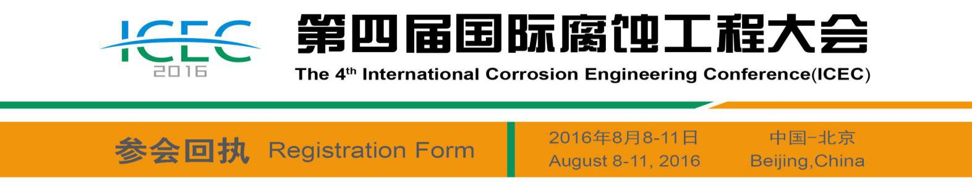

Company
Address
Name |  |  |  |  | Gender |  |  |  |  |  |  |  | Position
Phone |  |  |  |  | Fax |  |  |  |  |  |  |  | E-mail
Registration Categories and Fees
Categories |  | Advance Registration deadline：May 31，2016 |  |  |  |  |  |  |  |  |  |  |  | Regular Registration
Formal |  | $ 550 □ |  |  |  |  |  |  |  |  |  |  |  | $ 600 □
Student |  | $ 300 □ |  |  |  |  |  |  |  |  |  |  |  | $ 300 □
 |  | College |  |  |  | Major |  |  |  | Enrollment Date |  |  |  |  | Student ID
Give a lecture |  |  |  | □ |  |  |  |  |  | Publish Paper |  |  |  |  | □
Housing
Hotel |  |  | Swan Lake View Hotel
Room Type |  |  | Double □ |  |  |  | $110 |  |  |  |  | King Room □ |  |  |  |  |  | $110
Check-in Date |  |  |  |  |  |  |  |  |  |  |  | Check-out Date
Remarks
Registration fee covers all conference sessions, lunches, tea breaks, dinner and printed materials, but does NOT include accommodations. Please make your housing reservation in the conference registration form. Accommodation fees will be charged when you check in at the hotel. Prices may vary according to the current exchange rate.
Payment Information
Pay on-site □ |  |  | Cash □ |  |  |  |  |  |  |  |  | Credit Card □
Wire transfer □ |  |  | Beneficiary’s Name: BeiJing FengYingHuanShi Technology Company  Account No.: 0200006219200294824  Address: Room 806, FangXing Building, 30 XueYuan Road, HaiDian District, BeiJing, China  Tel: (+86) 10-82387692  Swift Code: ICBKCNBJBJM  Account with Institution：Industrial and Commercial Bank of China, BeiJing branch, Dongsheng Sub-branch
Signature |  |  |  |  |  |  |  |  |  |  | Date
Contact person: Xiaoyun Ju, Phone：(+86)10-62316606/(+86)18610933422 Fax：(+86)10-82387692 Email：icec@ecorr.org



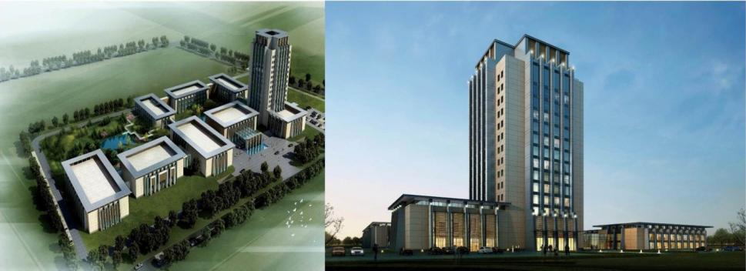
2014 Asia-Pacific Economic Cooperation remarkable (APEC) meeting, the "International Convention Center" held in Huairou. Swan Lake View Hotel BeiJing, Located in Huairou Yanqi River, close to Beijing International Convention Center, Investment by the China State Construction Engineering Corporation building, Managed by the Beijing BTG-Jianguo Hotel Management Company. Is a collection of accommodation dining, conference and leisure in one five-star hotel.Hotel construction area of approximately 54,000 square meters，Warm and elegant architectural design, the courtyard with the perfect blend of modern business. Hotel overall renovation in October 2012, re-opened in July 2014.
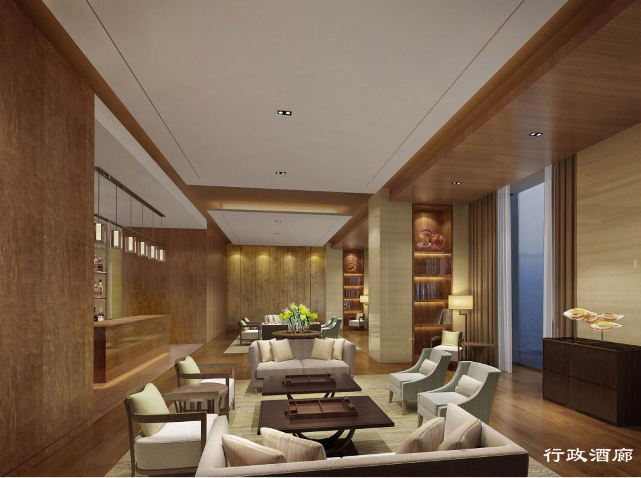
Convenient transportation, close to Beijing International Convention Center. 60 km from the center of Beijing, 40 kilometers from the capital airport, on the eastern side of the road Huaifeng direct access to Jingcheng Expressway. Surrounding scenic surround, 30 minutes to reach the Great Wall at Mutianyu, Hongluo Temple, Qinglong, Huaibei International Ski Resort and many other well-known tourist attractions.

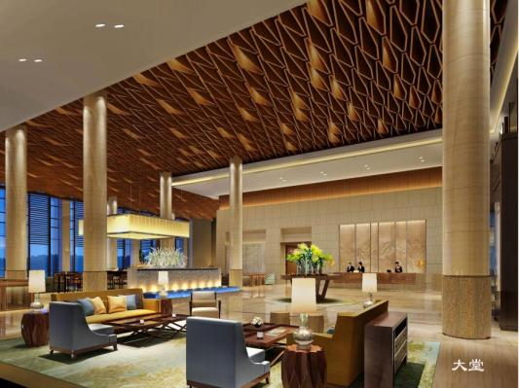

The hotel features 297 luxurious rooms of different styles，The top of the ad hoc Presidential Suite and Executive Lounge. which can host 450 guests; Hotels in the beautiful environment, Yanqi Lake View room can watch and enjoy the garden green.
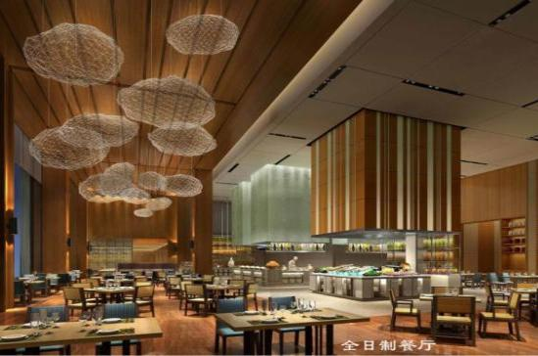

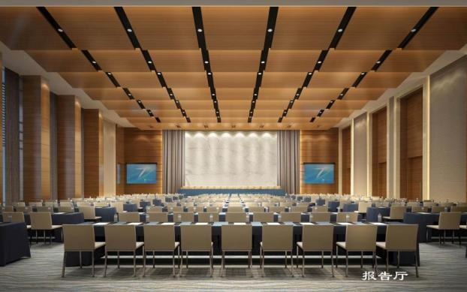
Restaurant Special the Grand Ballroom, full restaurant and bar with a view, tea house, which can accommodate 800 people dining, meet all kinds of large business dinners, receptions needs; Rich variety of dishes, the restaurant operates Yanxi health food and high-end French cuisine, unique flavor.The unique design of the ground floor restaurant, sunken courtyard and cascading landscape with elegant modern design and layout uncertainty highlight the distinguished quality.
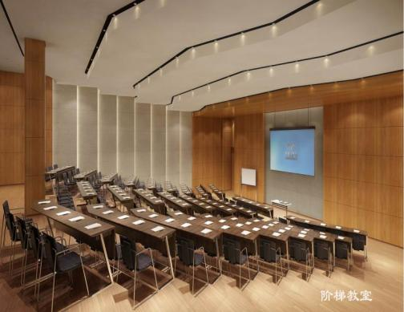

Meeting with modern facilities, offers 500 m2 multi-purpose hall and 10 meeting rooms of different sizes, the largest meeting room can accommodate up to 400 people meeting, suitable for all types of event. Recreational amenities include: tennis, badminton, swimming, golf simulation, KTV and billiard rooms and other fitness equipment, offers guests a casual and relaxed environment.
Check Swan Lake View Hotel, enjoy a welcoming environment and good service.
Add: 1 Yanqi Yan Sau Road, Huairou District, Beijing P.C.:101408

